Physiotherapy Exercises

Toe Walking- Session 1 Ball Exercises

instructions
1 | In front of mirror, have child put feet in your lap with hands on the floor. Get child to lift one hand at a time to wave to mirror.  Repeat 5 times per hand.  Hold each wave for a count of 5.  Alternative: child can wipe cream on mirror for 5 count or have a table set up in front of child to grab a toy from and then alternate 5 times per arm.
2 | Child can put torso on exercise ball and you can support them at the hips or waist. Child can put arms out like they are an airplane. You can get bubbles to help child stay interested or place newspaper shredding in front of them for them to blow away. Child can also pull pop it tube apart.  Repeat 5 times.  Hold position for 5 count at a time.
3 | Lay flat, keep knees on the ball and bring hips upwards  Hold for 5 count repeat 10 times
4 | Have child sit on ball and support their hips. Keep child’s feet straight and support their feet on your thighs. Slowly shift the child’s weight to the left, hold and then back to center and then to the right and hold.  Hold on each side for 5 count.  Repeat 5 times on each side.
5 | Have 1 person hold ball while child stands on ball. Provide support at their hips. Encourage bouncing on the ball with support.  Repeat-5 times | 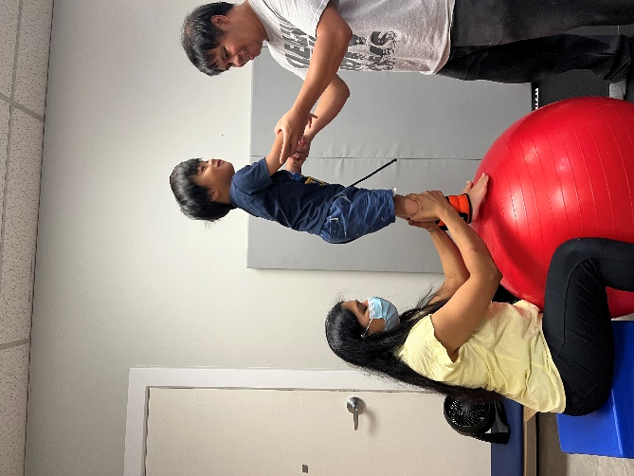
6 | Have 1 person hold bolster while child stands on bolster. Provide support at their hands. Encourage backward walking while you move the bolster forward.  Repeat-5 times | 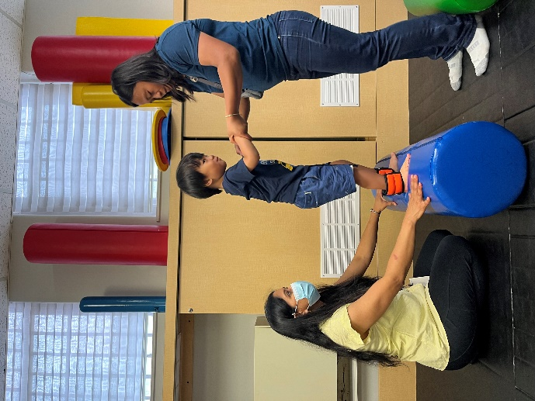
7 | The Rainbow Pass: Have your child start with the ball in their hands above their head. Then have the child lift the ball over their head while lifting their feet to the ball. The child will then place the ball in their feet and bring the ball down to the floor with their feet and then back up to pass to their hands. They will then repeat these steps, passing the ball between their hands and feet creating a “rainbow” shape.

