Physiotherapy Exercises

Toe Walking- Session 2 Stretching Exercises

instructions
1 | Use a specialized brush to brush the soles of the feet with joint compressions. | 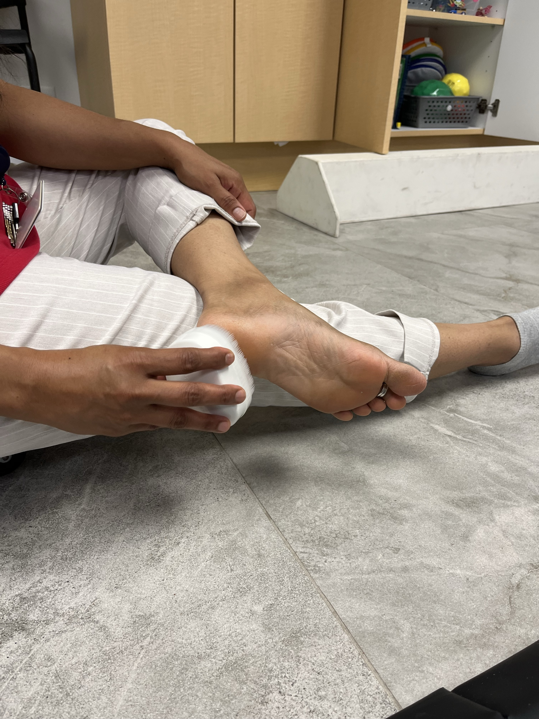
2 | Have child sit on a scooter board with their feet in front of them. Place heels on the ground and toes up in the air. Use their heels to press into the ground and propel themselves forward. | 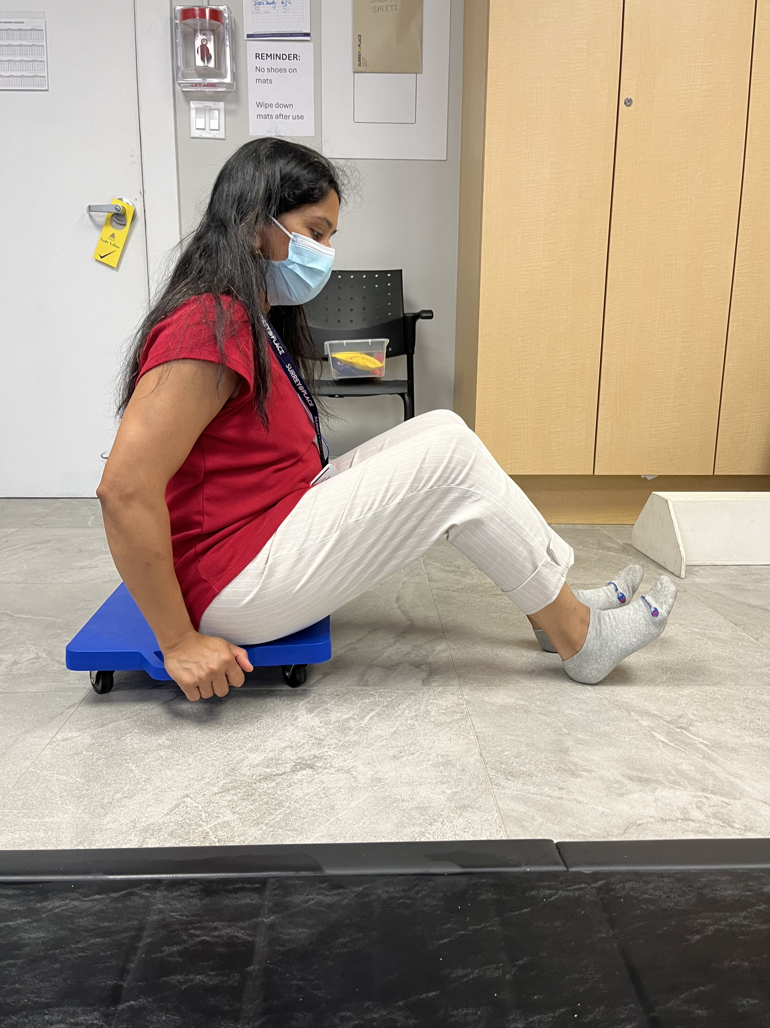
3 | Sit on a chair or stool. Place your hands above his/her ankles, providing moderate and constant pressure downward to keep their heels on the floor. practice standing up and down while keeping their heels on the ground | 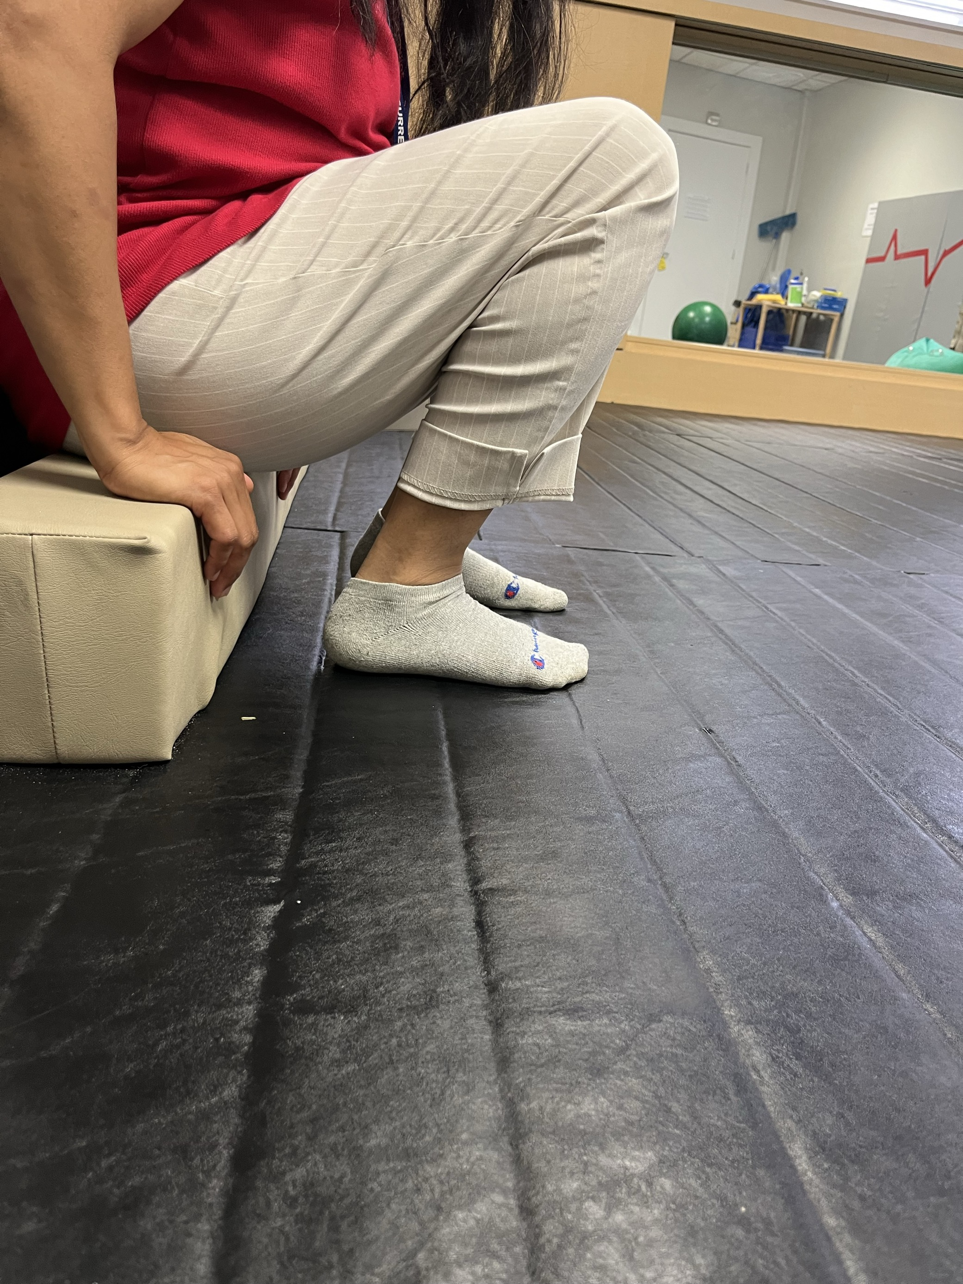
4 | Stand on a wedge with knees straight and heels on the wedge. You can use a wedge, as pictured, or use a board with books under 1 side to give a slight angle. | 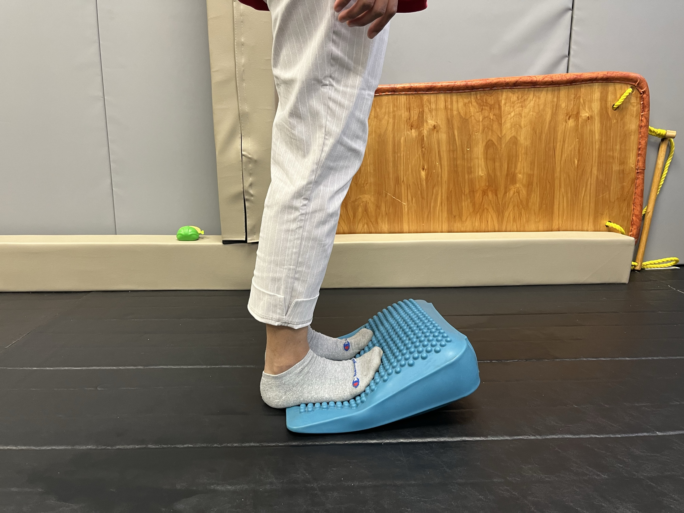
5 | Crab walk  Complete 15- 20 steps per day | 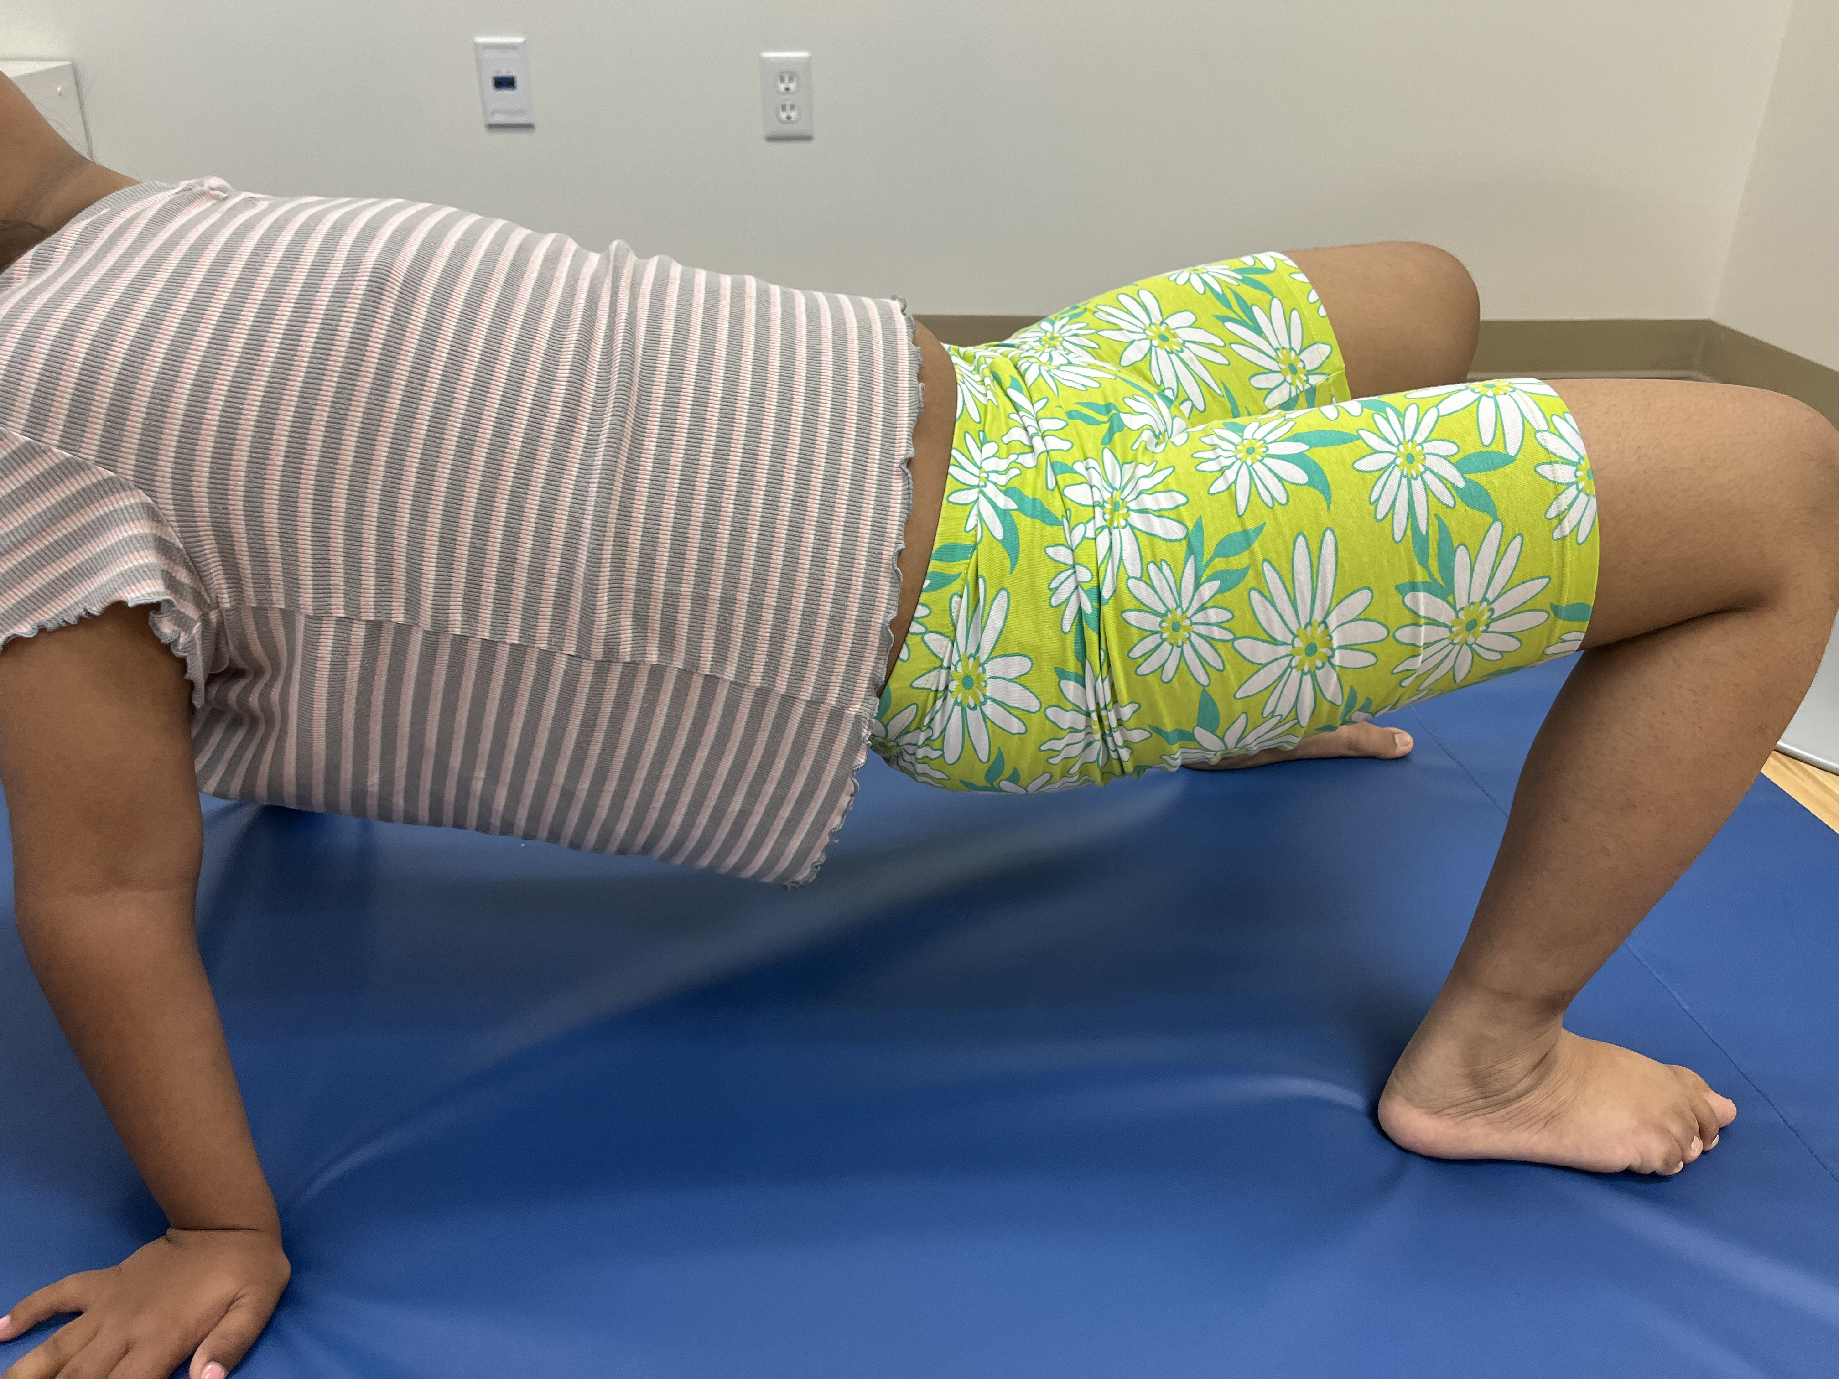
6 | Have your child sit in a chair or stand. Start with sitting and as he/she gets stronger, progress to standing. Place a bean bag on top of his/her foot and have your child transfer it to a bucket or basket. As your child gets stronger, he/she can lift the bean bag off the floor by themselves. | 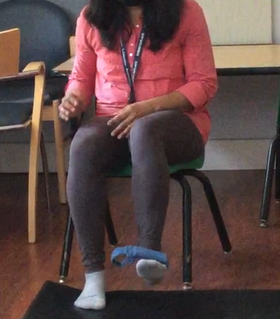
7 | Bear walk  Complete 15- 20 steps per day. Keep both legs and feet turned outside while walking in all the exercises. Avoid toe walking. | 