Physiotherapy Exercises

Toe Walking- Session 3 Strengthening Exercises

instructions
1 | Encourage your child to move his foot up against the resistance of theraband  Repeat 10 times  1-2 times per day  5 counts hold  . | 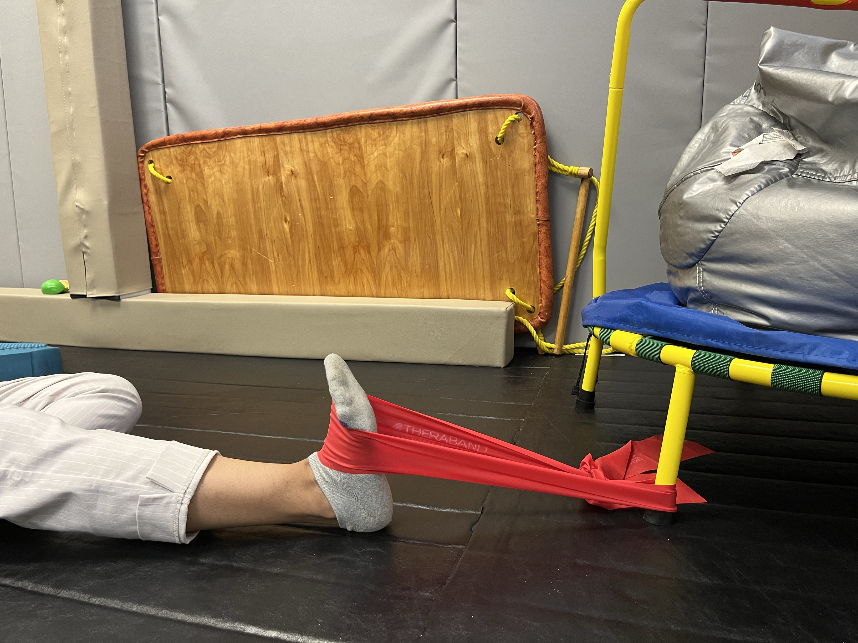
2 | dynamic activities that challenge core strength include seated/standing balance on dyna-disc or tilt board | 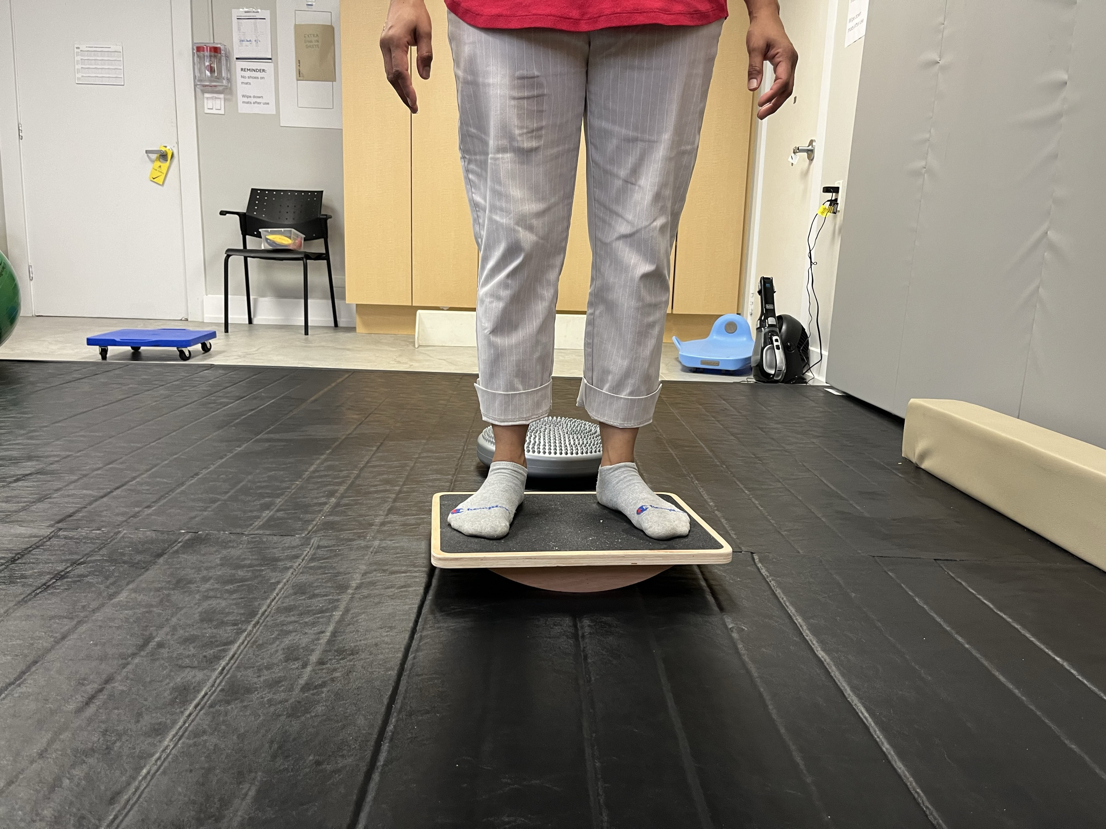
3 | Encourage barefoot standing using a variety of textures, promote squat to stand with fun activities to facilitate weight bearing. | 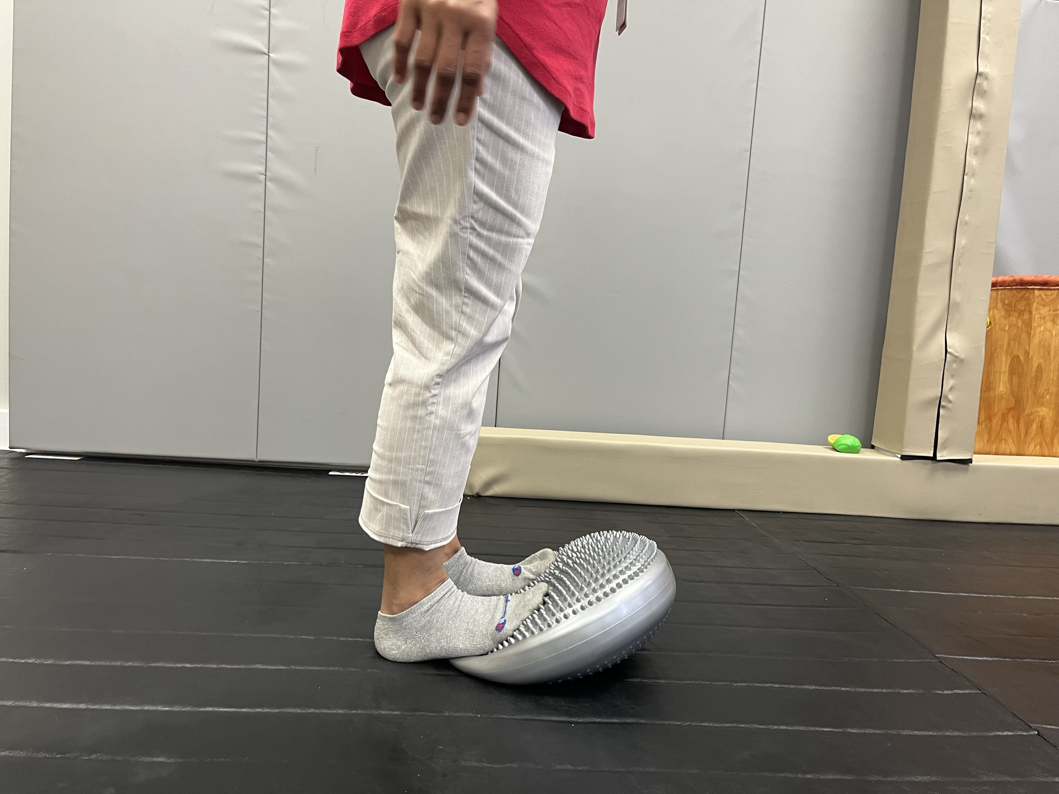
4 | you can target these small muscles by picking up objects with toes. Try “toe basketball” lifting small pompoms with feet and placing into cup to score!  Repeat 5 times  1-2times per day | 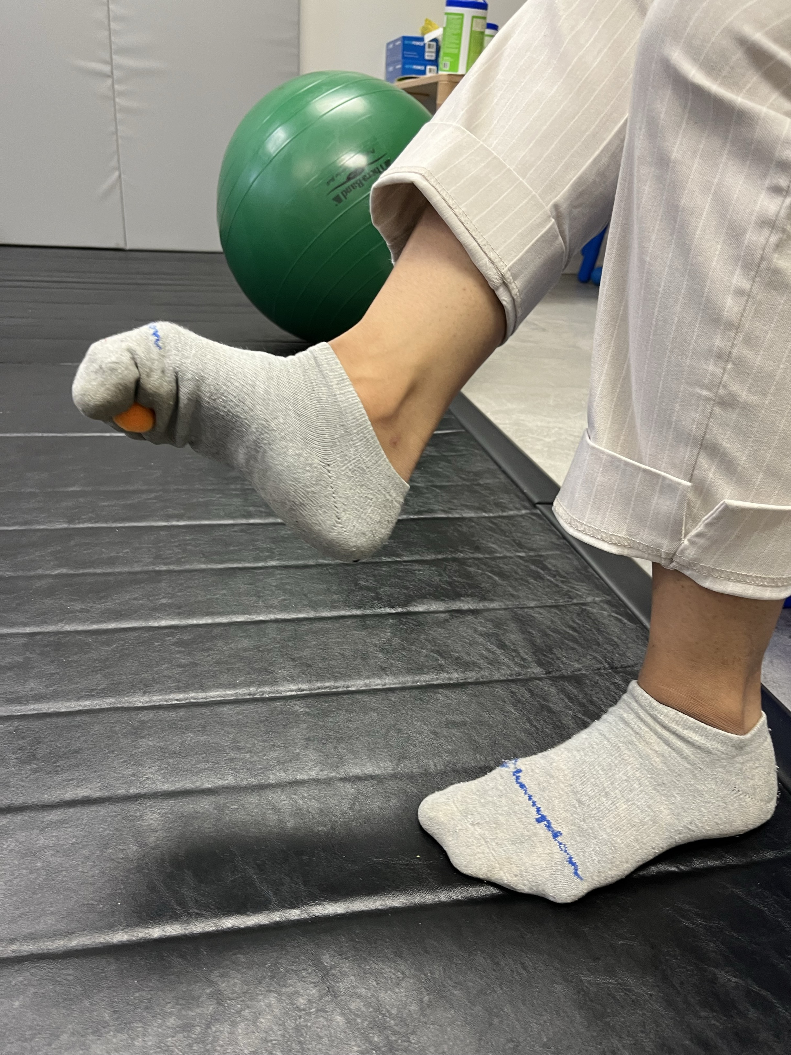
5 | Ask your child to walk backwards against the resistance of the theraband.  Repeat 10 times  1-2 times per day | 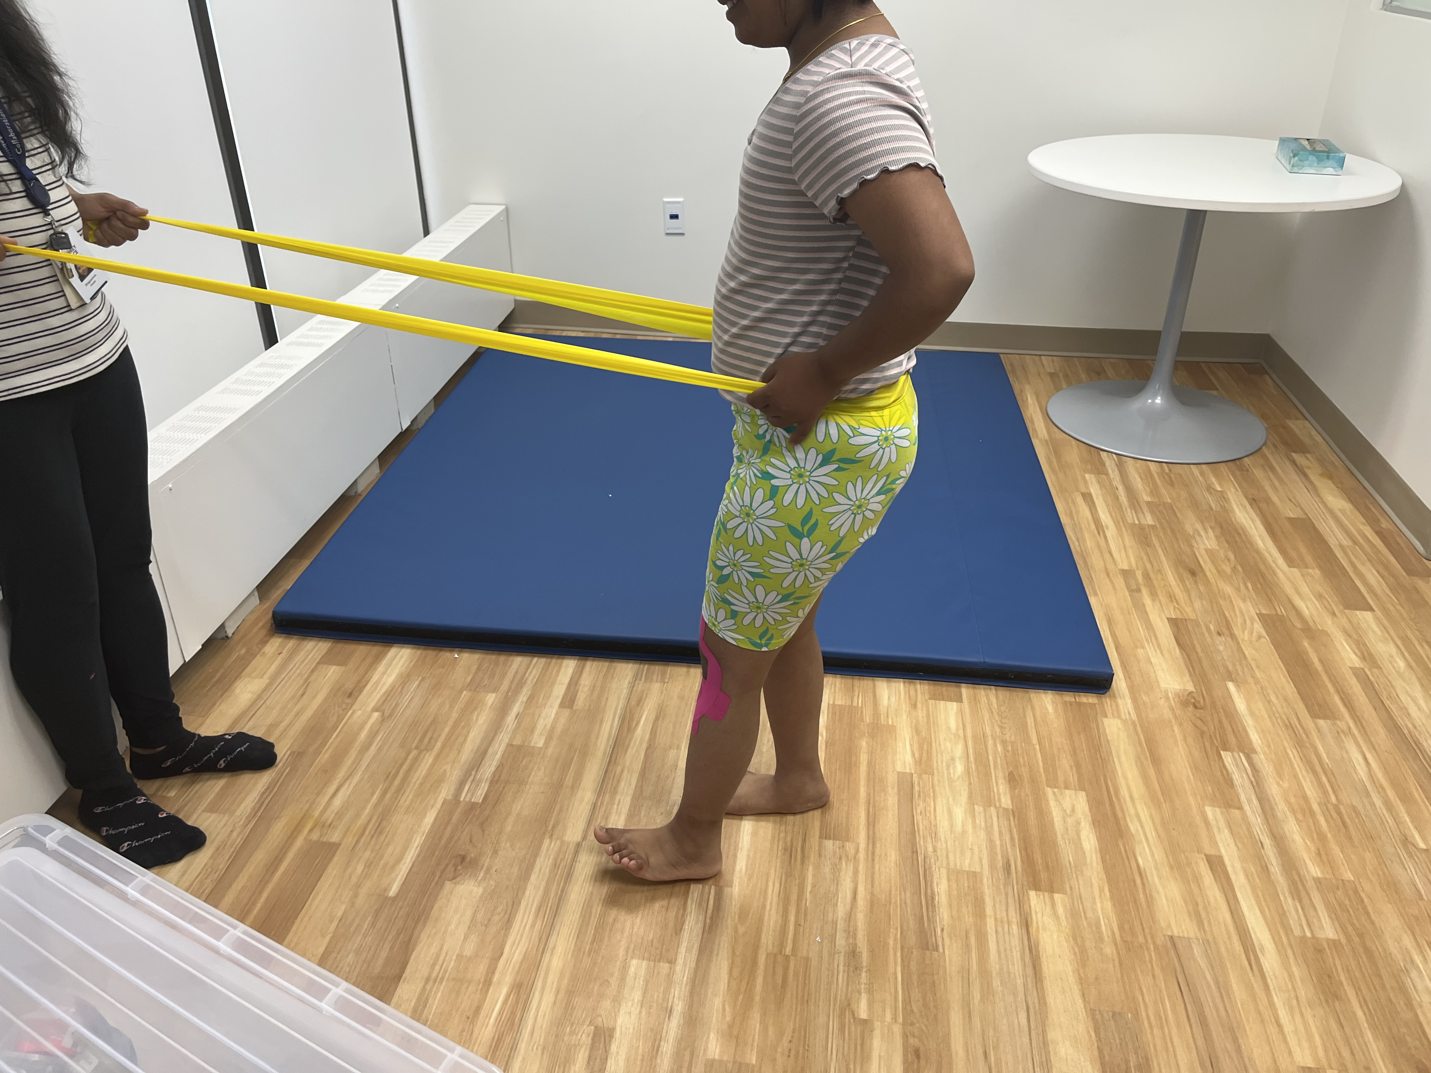
6 | Squats on the foam balance pad | 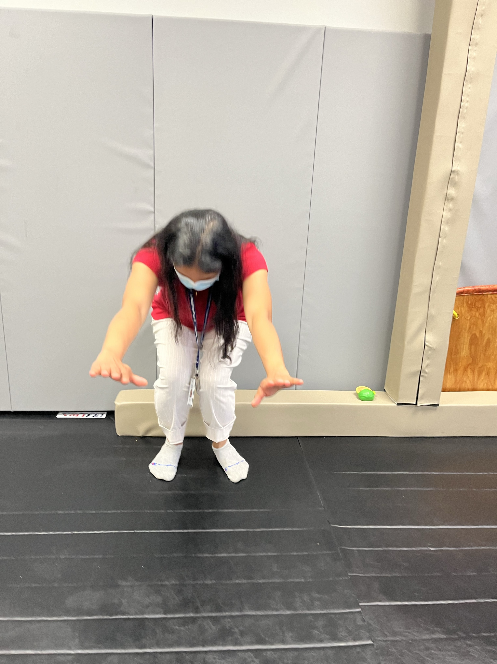
7 | A hoop ladder is great for weight bearing and strengthening  "https://amzn.to/2ZWdVO3" | 

